# Algorithm for file updates in Python

## Project description

At my organization, access to restricted content is controlled with an allowed list of IP addresses. The "allow_list.txt" file identifies these IP addresses. A separate remove list identifies IP addresses that should no longer have access to this content. I created an algorithm to automate updating the "allow_list.txt" file and remove these IP addresses that should no longer have access.

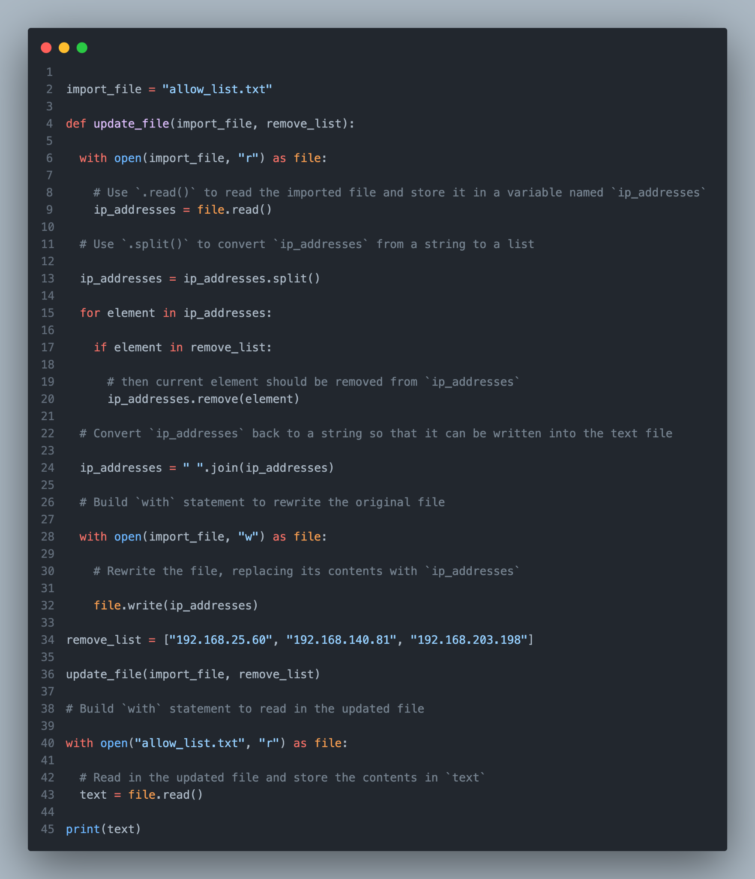

Function: update_file(import_file, remove_list)

Purpose: This function removes specified IP addresses from a text file named "allow_list.txt".

## Parameters:

**import_file**: (str) The path to the file to be updated. Defaults to "allow_list.txt".

**remove_list**: (list) A list of IP addresses to be removed from the file.

## Steps:

1. **Open the file:** The function starts by opening the import_file in read mode using a with statement.
2. **Read the file contents:** The entire file content is read into a variable named ip_addresses using the read() method.
3. **Convert to a list:** The ip_addresses string is split into a list of individual IP addresses using the split() method.
4. **Iterate and remove unwanted IPs:** A loop iterates through each element in the ip_addresses list. If the element (IP address) is present in the remove_list, it is removed from the ip_addresses list using the remove() method.
5. **Convert back to string:** The updated ip_addresses list is converted back into a string with each element separated by a space using the join() method.
6. **Rewrite the file:** The import_file is opened again in write mode using another with statement. The updated ip_addresses string is written back to the file using the write() method, effectively replacing the original content.
7. **(Optional) Read and display updated file:** The script demonstrates reading the updated file content and displaying it using another with statement and read()/print() methods.

## Summary:

The update_file function provides a convenient way to remove unwanted IP addresses from a text file. It iterates through the file content, removes specified entries, and rewrites the entire file with the updated list. This function can be used to maintain a whitelist or blacklist of IP addresses for various security or access control purposes.

Additional notes:

* The function assumes the provided remove_list contains valid IP addresses.
* Error handling could be added to address potential issues like invalid file paths or invalid IP addresses in the list.